Local and Global Variables

Globle space :-
the area present outside the function is called as globle space.
Local space :-
the area present inside the function or method area is called as local space.

global variables :-
in the case of globle variable we can accessed and modified in main space.
but inside the local space we can only access global variable but we can't modified it .

Eg.
a=10
b=20
def demo():
print('hii')

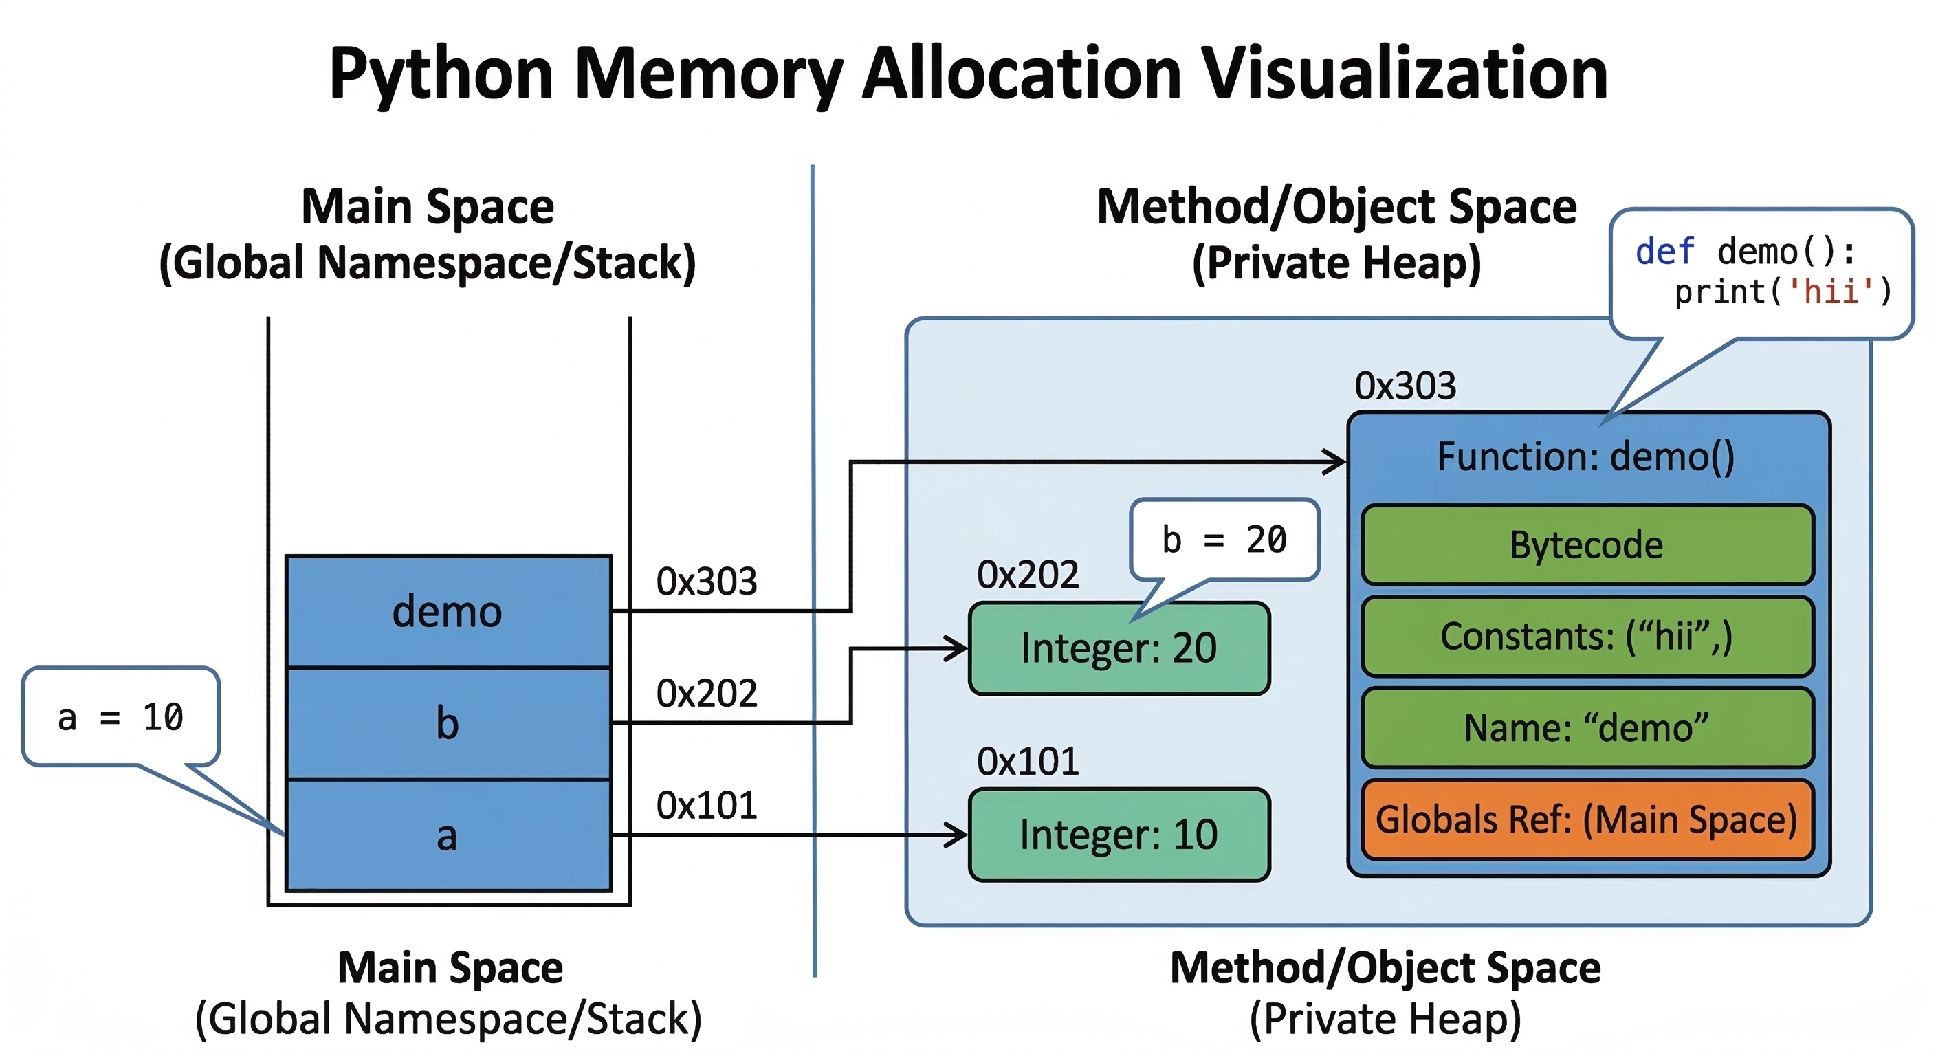

Eg.
a=10
b=20
def demo():
print('hii')
demo()
print(a)
a=30
print(a)

